Abstract Preparation Instructions for the NUCAR-2023 Symposium

A. Xyz^{1,§}, B.A. Author^{,2} and C.D.E. Third author²

¹ Department, University, City, Country
² Institute, City, Country
§ Email: corresponding author

This template contains abstract preparation instructions for the 16th DAE-BRNS Nuclear and Radiochemistry symposium (NUCAR-2023). The abstract must be written in English and its extent is limited to only one A4 page (with 2.5 cm margins, top 3.0 cm) including the figures and tables, references and acknowledgements if any. The title of the abstract should be typed using the 14 pt Times New Roman bold font. The names of the authors and their affiliations should be then typed with the 12 pt Times New Roman font using the regular and italic font style, respectively. The title, author names and their affiliations should be centered and mutually separated by one empty line. Please underline the name of the presenting author and use § to indicate corresponding author.
The body of the abstract should be typed again using the 12 pt Times New Roman font and single line spacing. The text has to be justified. There should be one empty line between the abstract body and the preceding part of the abstract. You may also include equations, tables, figures (see Fig. 1) and references [1]. Leave empty line between body of the abstract and the references. If an equation is given, like Eq. (1),
(1)
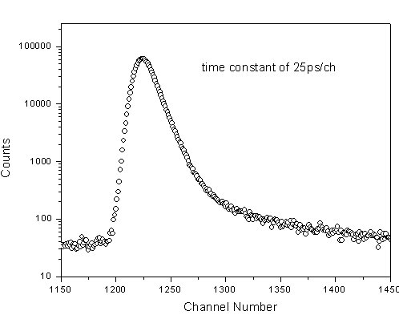
the Microsoft (MS) equation editor only should be used.
Abstracts should be categorized (A to I) as per the titles given under SCOPE of the symposium. However, depending on the referee’s comments, the same might be changed.
All participants of NUCAR-2023 are requested to get registered in advance by filling the registration form online at www.iancas.org/nucar2023. All the participants need to create a ‘user account’ at this web site to submit the one page abstract. E-mail ID of
Fig. 1: Please use ONLY black and white figures. Figure (and table) captions should be typed using the 11 pt Times New Roman font. The text can be aligned with the figure.
corresponding author should be given and presenting author should be underlined.
Authors may note that it is mandatory to provide E- mail addresses of all the authors of a particular manuscript during paper submission.

Acknowledgements, if any, should be located here and separated by one empty line from the material given above.

References:
[1] G. Author and H. Coauthor or I. Author et.al., Journal Name, volume (Year of publication) First page number.

